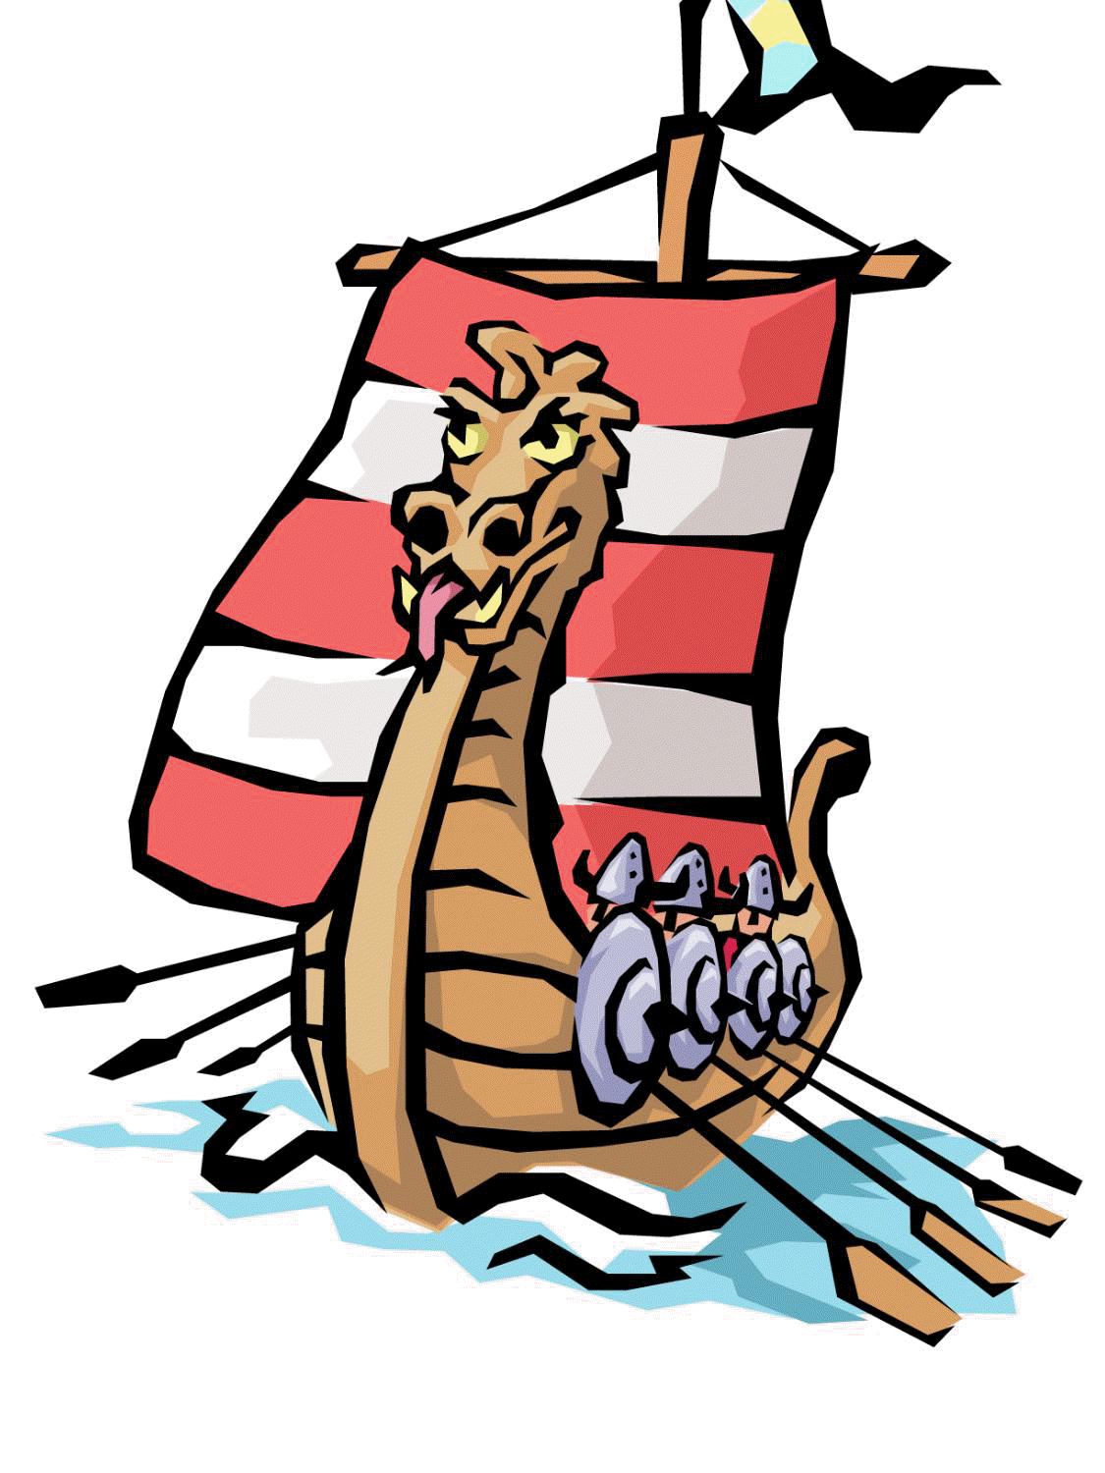

Autumn 2023

**Invasion**

**Local links and Exciting experiences**

Hunston nature walk – 22nd September

Weald and Downland Saxon workshops – 19th September

**Jigsaw- Lifeskills**

‘Being me in my world’ – feeling connected in our school family and helping others. Key aspects of being a good friend to others.

**RE**

Understanding the Jewish weekly day of rest – Shabbat, before examining Kathina (the end of Buddhist Lent).

**History/Geography**

Finding out how and why our country was invaded by different groups, as it began to resemble the country we live in today.

**Art & Design**

Paints, oil pastels, watercolours and sketching. Building on and applying skills, examining and replicating patterns, learning about weft and weave

**Science**

Understanding food and the digestive system.

**Computing**

Internet safety, investigating abstraction of ideas (reducing a concept to basic parts)

**Design technology**

After examining a range of artefacts, creating several replicas and models to encourage deeper understanding

**PE**

Mondays – PE coaches, sports-based learning with skills leading to games.

Thursdays – Hall, footwork, co-ordination, static balances. Working collaboratively

**Music**

To develop and understanding of Gospel music and to sing in a Gospel style with expression and dynamics.

**Main subject for topic**

How did life alter under different cultures, and who were some of the main players who shaped Britain over a 700- year period of upheaval and change?

**Maths**

1 st KIRF (number pairs to make 100)

I Rounding, partitioning, comparing and ordering numbers to 10,000.

II Roman numerals and negative numbers.

III Perimeter and length. I

V Add and subtract 4-digit numbers.

V Multiplication and division.

**English Key Texts**

Arthur and the Golden Rope (Narrative)

Gut Garden (Digestion Explanation)

**Reading**

The Butterfly Lion Michael Morpurgo

**Please keep reading at home**

Brief outline of Learning Journey:

**What happened in Britain after the Romans left in 410AD?**

**Looking at Anglo-Saxons and Vikings up to the Norman Battle of Hastings (1066AD)**