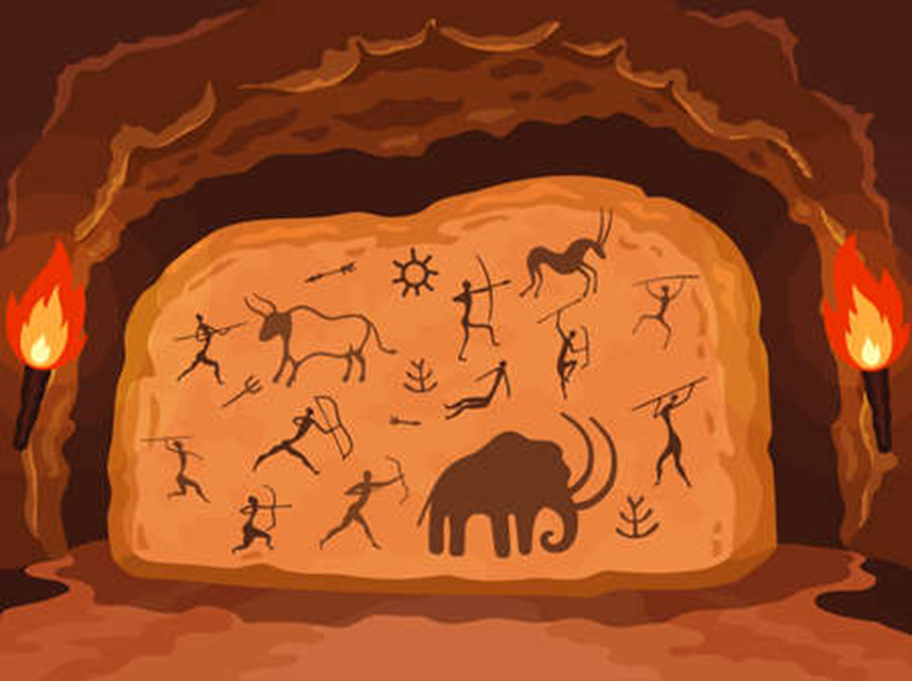 **Through the Ages**

**Local links and Exciting experiences**

Trip to Butser Ancient Farm 13th September

**Main subject for topic- History**

**Context-** Prehistoric Britain

**Skills developed**- order dates chronologically, make comparisons to modern day everyday life.

**Knowledge** - learn about inventions discovered in pre-historic Britain and learn about the people and lifestyles in pre-historic Britain.

**Science**

**Context: Animals, including humans**

**Skills developed:**  Set up and carry out some simple fair tests and make predictions, using suitable vocabulary to talk and write about what they have done and what they have found out. Make careful observations, gather and record findings in a variety of ways and take measurements in standard units. Compare and contrast the diets of different animals. Describe how humans need the skeleton and muscles for support, protection and movement. Identify and group animals that have no skeleton, an internal skeleton and an external skeleton.

**Knowledge –** learn what tests, predictions, results and conclusions are, that data can be recorded and displayed in different ways, that equipment is used to take measurements and an observation involves looking closely. Also that animals cannot make their own food and need to get nutrition from the food they eat, to name major bones, muscles and organs in the human body and that animals have different types of skeleton – some have none.

**Autumn Term 2023**

**Brief outline of Learning Journey:**

**A history based learning journey that will explore many aspects of British prehistory from the Stone age to the Iron Age.**

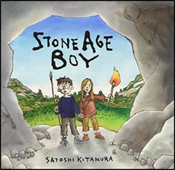

**PE**

Mondays- swimming – see separate letter

Thursdays- Games skills and gymnastics- Mrs Berger

**Jigsaw- Lifeskills**

Autumn 1: Being me in my World

**Maths**

**Main focus- place value, addition and subtraction.**

**KIRFs- recall all number facts to 20.**

The children will also be

* Using hundreds, tens and ones
* Ordering and comparing numbers, using <, > and =
* Finding 1, 10 and 100 more or less
* Adding and subtracting.

**Computing**

**Context – Computing systems and networks**

**Skills developed –** to give examples of inputs, outputs and processes.

**Knowledge -** to develop understanding of digital devices, and to learn about computer networks and the benefits of connecting devices to a network.

**English**

**Key Texts-** Stone Age Boy and Skara Brae

**Reading-** we will be exploring stories and non-fiction as well as taking part in the reading challenge.

**Writing-** Children will be learning to- use punctuation including question marks, continuing to join handwriting correctly and learning spelling rules and using them in their writing.

**RE**

In RE the children will be comparing different religions and beliefs by learning about the Hindu festival of Ganesh Chaturthi and the Sikh festivalGuru Nanak Gurpurab.

**Art and Design**

**Context: Contrast and Complement**

**Skill**: Use preliminary sketches in a sketchbook to communicate an idea or experiment with a technique.

**Knowledge** – learn that watercolour paint is a translucent paint, which can be made bolder and stronger by layering.

**Music**

In music the children will explore a wide range of musical styles. They will have opportunities to develop their listening, singing, playing, composing and performing skills.