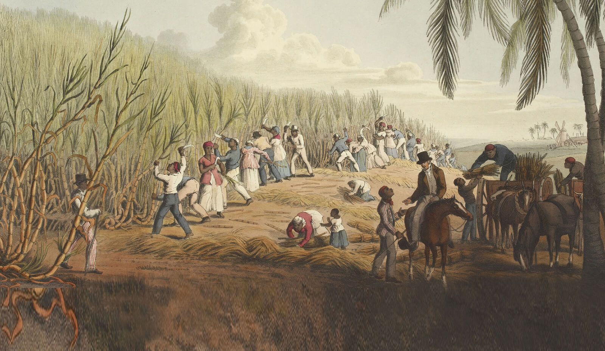

**MAAFA ‘great tragedy’**

**Science**

**Context: Animals, including humans**

This project teaches children about the transport role of the human circulatory system, its main parts and their primary functions. They learn about healthy lifestyle choices and the effects of harmful substances on the body.

**Skills developed:**

* Plan different types of scientific enquiries to answer questions, including recognising and controlling variables where necessary.
* Describe the ways in which nutrients and water are transported within animals, including humans.
* Use test results to make predictions to set up further comparative and fair tests.

**Knowledge and key vocabulary:**

* Know the risks associated with an inactive lifestyle (including obesity).
* Know what constitutes a healthy diet (including understanding calories and other nutritional content).
* The role of the circulatory system is to transport oxygen, water and nutrients around the body. They are transported in blood and delivered to where they are needed.

Author Visit: Tuesday, 4th October we will welcome Richard Pickard to our school and read some of his book, then encourage everyone to finish it -all children will be given their own copy!

**Brief outline of Learning Journey:**

*This project teaches children about Africa past and present and the development of the slave trade. It also explores Britain’s role in the transatlantic slave trade, the causes and consequences of the European colonisation of Africa and the worldwide communities that make up the African diaspora.*

**Maths**

**Main focus- place value, multiplication, division, multiples, primes and square numbers**

**KIRFs- multiplication and division facts up to 12 x 12**

The children will also be:

* Learning the long division strategy
* Recapping addition and subtraction
* Problem solving and reasoning

**Year 6 Autumn Term 2023**

**Main subject for topic- History**

**Context-** African history linked to slavery and abolition

**Skills developed**- To describe the impact on British life; to describe causes and consequences of significant events; articulate a clear, chronological world history narrative.

**Knowledge and key vocabulary**- to understand how the British economy grew between the 16th and 19th centuries due to a range of factors including Britain’s involvement in the slave trade, the plantation economy in the New World, Colonialism, new inventions and the Industrial Revolution. This growth had far-reaching consequences and changed many aspects of people’s lives including the way they worked, travelled and spent their money.

**English**

**Key Texts-** There May Be A Castle and Freedom 1783. Author visit -Gary Northfield

**Reading-** we will be exploring vocabulary and skills of inference and retrieval in stories and non-fiction and analysing these texts.

**Writing-** Children will be writing Newspaper reports. They will be completing a text analysis and studying puns, time adverbials, active and passive voice. They will then move to a TWS story unit called ‘The Journey’, thinking about issues surrounding refugees including fear of the unknown but also hope.

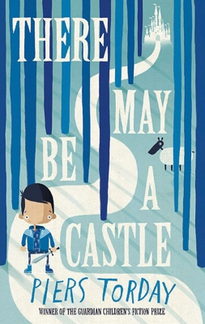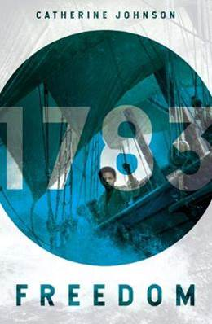

**RE-** In RE the children will be comparing different religions and beliefs by learning about the Jewish festival of Rosh Hashana and Yom Kippur and the Sikh festivalBandi Chhor Divas.

**PE**

Tuesday – Real P.E. Core skills and ball games

Wednesday – PE coaches – games skills



**Computing**

**Scratch Animation -** The unit is designed to help children in continuing to develop their skills in writing their own algorithms as well as editing and debugging existing codes. New skills are introduced to structure code and animate characters and scenes, gradually building to create a short animated story.

**Maafa**

**Music**

All the learning in this unit is focused around one song: Happy, a Pop song by Pharrell Williams.

The material presents an integrated approach to music where games, the dimensions of music (pulse, rhythm, pitch etc), singing and playing instruments are all linked.

**Art and Design**

**Context 1:** This project teaches children about colour theory by studying the colour wheel and exploring mixing tints, shades and tones. They learn about significant landscape artworks and features of landscapes before using this knowledge to create landscape paintings.

**Skills developed:** Gather, record and develop information from a range of sources to create a mood board or montage to inform their thinking about a piece of art.

**Knowledge:** A mood board is an arrangement of images, materials, text and pictures that can show ideas or concepts. A montage is a set of separate images that are related to each other and placed together to create a single image.

**Geography.**

**Context: Our Planet, Our World**

This essential skills and knowledge project revises the features of Earth, time zones and lines of latitude and longitude to pinpoint places on a map. Children find out more about map scales, grid references, contour lines and map symbols. They learn about climate change and the importance of global trade. Children analyse data and carry out fieldwork to find out about local road safety. They study patterns of human settlements and carry out an enquiry to describe local settlement patterns.

**Design technology**

This project teaches children about processed food and healthy food choices. They make bread and pasta sauces and learn about the benefits of whole foods. They plan and make meals as part of a healthy daily menu, and evaluate their completed products.

**Skills:**

* Create a detailed comparative report about two or more products or inventions.
* Analyse how an invention or product has significantly changed or improved people's lives.

**Knowledge:**

* Products and inventions can be compared using a range of criteria, such as the impact on society, ease of use, appearance and value for money.
* A processed food is changed during preparation and includes processes, such as cooking, freezing, pasteurising, or the addition of ingredients. Pros of processed foods include convenience and availability. Cons include a lack of nutrients and unhealthy ingredients.

**Local links and Exciting experiences**

Trip to the British Museum Thursday, 2nd November

Outside learning This includes walk with Y1 buddies and art experience by the local lakes.



**French:**

**1st half term-** As tu un animal?- learn to talk about our pets in French.

**2nd half term-** Au Salon du thé- talk about a wide range of foods and how to order them.

Remember and recall a wide variety of foods, snacks, and drinks (with their indefinite article/determiner) typically served in a salon de thé. • To understand better how to change a singular noun to plural form. • Perform a short role-play ordering what they would like to eat and drink

**Jigsaw- Lifeskills**

Autumn 1: Being me in my World

Autumn 2: Celebrating Difference