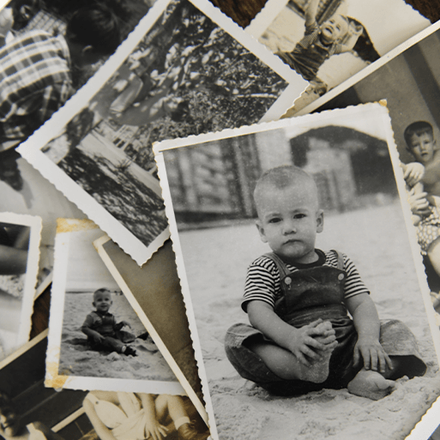Childhood  
Autumn Term

**Maths**

**Main focus-** Place Value, Addition and Subtraction and Shape.

**Autumn 1 KIRF-** Recall numbers to 20.

**Spiring 2 KIRF** – To know their number bonds to 6.

**Brief outline of Learning Journey**

A history based project which teaches the children about everyday life and families today, including comparisons with childhood in the 1950’s, using artefacts and a range of different sources.

**English  
Key Texts-** Julia Donaldson books – The Gruffalo, What the ladybird heard, Stickman, Monkey Puzzle. **Reading –** We will be exploring both fiction and non-fiction books.  **Writing –** We will be writing in a range of styles including story writing and information texts. Children will be learning to use capital letters, full stops and finger spaces in the writing as well as beginning to use adjectives.

**Music**

**Autumn 1:** Menu Song

The children will participate in creating a dramatic group performance using kitchen-themed props. They will listen and move in time to a song and copy a leader in a call and response song.

**Autumn 2:** *Colonel Hathi’s march*

The children will compose music to parch to using tuned and untuned instruments. They will respond to musical characteristics through movement.

**Science**

**Autumn 1 Context:** Everyday Materials  
**Knowledge:** The childrenwill learn that materials are what objects are made from. They will observe and identify objects made from different materials in places familiar to them, such as their home and school. They will explore human-made materials looking at their properties and comparing them to a range of other materials.   
**Key Vocabulary:** Materials; Natural materials; Human-made materials; Grouping materials; Properties of materials; Venn diagrams; Comparing and testing materials.

**Autumn 2 Context:** Human Senses  
**Knowledge:** The children will learn that humans are a type of animal known as a mammal. They name and count body parts and identify similarities and differences. They learn about the senses, the body parts associated with each sense and their role in keeping us safe.  
**Key Vocabulary:** Sight, Hearing, Smell, Taste, Touch, Senses, Sensory.

**Main subject for topic - History**

**Context:** Childhood  
**Knowledge:** In the Childhood project the children will learn words and phrases related to the passage of time. They will explore artefacts to help them to understand childhood in the past and how childhood has changed over time. They will explore the six stages of life and explore timelines and family trees. Everyday life in the 1950s will be explored, including shopping, transport, family life and childhood. They will also learn about the significance of Queen Elizabeth II's coronation in 1953 by studying photographs and online sources. The children will use maps to explore how places have changed over time and highlight any similarities or differences between childhood today and childhood in the 1950s. At the end of the project, they will create knowledge organisers for children who are about to study the topic of childhood.



**PE  
Tuesday** – Real PE   
*Autumn 1*: Personal - Follow instructions Work safely  
*Autumn 2*: Social - real PE Follow instructions Work safely  
**Wednesday** - PE with the Brighton Coaches

**Jigsaw- Life Skills**

**Autumn 1:** Being Me

**Autumn 2:** Celebrating Differences

**Geography**

What a wonderful world

In the Our Wonderful World project, your child will learn the meaning of the terms geography, physical feature and human feature. They will use maps, including picture maps, globes, online mapping tools and world maps. They will also become familiar with the cardinal compass points, north, south, east and west. They will learn the names and positions of the continents and oceans of the world and understand the terms equator, Northern Hemisphere and Southern Hemisphere.

**Key words:** Physical and human features; Picture maps; Cardinal compass points; Equator and hemispheres; Continents; Oceans; Countries and capital cites of the UK; Protecting natural environments; Fieldwork

**Art & Design**

**Autumn 1 Context:** Mix it up

**Knowledge:** This project teaches children about basic colour theory by studying the colour wheel and colour mixing. It includes an exploration of primary and secondary colours and how artists use colour in their artwork.

**Key vocabulary:** Primary colours, Secondary colours, watercolours.

**Autumn 2 Context:** Funny Faces and Fabulous Features.

**Knowledge:** This project teaches children about the concept of the portrait and how the collage technique can be used to make a portrait.

**Key vocabulary:** Sketching, portrait.

**Computing**

Throughout Autumn 1 we will learn how to log on to the computer and load a programme. This will then lead into Autumn 2 where we start exploring word processing. We will practice typing with two hands, use shift and enter correctly and changing the font, colour of the writing.

**RE**

**Autumn 1:** In Autumn 1 the children will be learning about Christianity and their festivals.   
**Keywords**: Bible, charity, Christian, creation, grateful, harvest, hymns, miracle, share, thankful, worship.  
**Autumn:** In Autumn 2 our RE focus will be Hinduism focussing on the festival Diwali.  
**Keywords**: Arti, barfi, demon, dhal, diva lamps, Lakshmi’s footsteps, mandir, mehndi, murti, puja, rangoli.

**Design technology**

**Context:** Shade and Shelter

**Knowledge:** This project teaches children about the purpose of shelters and their materials. They name and describe shelters and design and make shelter prototypes. Children then design and build a play den as a group and evaluate their completed product.